Your title
Author 1^{a,}*, Author 2 ^{b}, Author 3 ^{c}, Author 4 ^{d}
ª Affiliation A, ^{b} Affiliation B, ^{c} Affiliation C, ^{d} Affiliation D
corresponding.author@email.com

Abstract
The abstract should be one column formatted and contain about 100 to 300 words. Please do not use references in the abstract.

1. Introduction
The paper structure is exemplary and can be adjusted according to your needs. The standard text size is 10 pt, and we use Times New Roman as the standard font. Paragraphs are not indented and the alignment is “justified”. Please do not add page numbers since they will be added in the final conference proceedings layout.
Figures should have a width of 6.5 cm and be placed in the text when first mentioned and centered. The caption is placed below; the caption font is Times New Roman, non-italic, font size 9. See for example Fig. 1.
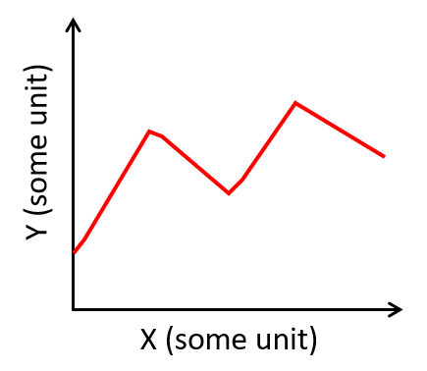
Figure 1: Add your caption here.
Tables should be centered and the caption placed above. The caption font is Times New Roman, non-italic, font size 9. Place the table when first mentioned and refer like this: Tab. 1
Table 1: Add your caption here.
ID | Property 1 | Property 2 | Property 3
1 | A | B | C
2 | D | E | F
3 | G | H | I
Footnotes should be places after punctuation characters, without any spaces between said characters and footnotes, like this example.
Equations are numbered continuously:

$$\begin{aligned}∆U= ∆Q+ ∆W\#\left(1\right)\end{aligned}$$
$$\begin{aligned}∆S=\frac{{∆Q}_{rev}}{T}\#\left(2\right)\end{aligned}$$

The bibliography is embedded at the end of to the main latex document. Examples referring a book (Mittelbach et al., 2004), a journal paper (Knuth, 1984)[2] and a conference paper (Lesk and Kernighan, 1977)re provided.

2. Methodology
Subsections and subsubsection are numbered with Arabic numbers and italicized

2.1. Subsection

2.1.1. Subsubsection

3. Results

4. Summary and Discussions

Acknowledgment

References

Knuth, D. E. (1984) ‘Literate Programming’, The Computer Journal. Oxford Academic, 27(2), pp. 97–111. doi: 10.1093/COMJNL/27.2.97.
Lesk, M. E. and Kernighan, B. W. (1977) ‘Computer typesetting of technical journals on UNIX’, AFIPS Conference Proceedings - 1977 National Computer Conference, AFIPS 1977. Association for Computing Machinery, Inc, pp. 879–888. doi: 10.1145/1499402.1499562.
Mittelbach, F. et al. (2004) The LaTeX Companion. 2nd edn. Addison-Wesley Professional.

This is a footnote.

